ESD Team Analysis

Contents

Introduction 1

1: My Own Strengths and Weaknesses 1

Myers-Briggs 1

Team Roles (Appendix, TABLE – HJM1) 2

Multiple Intelligences (Appendix, TABLE – HJM2) 2

2: Team analysis 3

Strengths and Weaknesses 3

How well will we work? 3

References 3

Appendix 4

Harrison Marcks (ENTJ) Test Results 4

Dan Steer (ISFJ) Test results 4

Hüseyin Sert (ENFJ) Test Results 5

Jesse Bat (ENFP) Test Results 6

# Introduction

To better understand our teams, and our roles within them, we have been tasked with taking various personality, intelligence and team role tests. The results of these tests will be used to analyse how our team will work and fit together and to attempt to predict our behaviours as a team.

We will start with an analysis of my own strengths and weaknesses regarding these tests, followed by a general appraisal of the entire team’s strengths and weaknesses.

# 1: My Own Strengths and Weaknesses

## Myers-Briggs

According to my Myers-Briggs (MB) results, I am of Extroverted, Intuitive, Thinking, Judging (ENTJ, Executive) characteristics.

As far as strengths are Concerned I am labelled as efficient, energetic, self-confident, strong-willed, a strategic thinker and charismatic/inspiring. Often labelled as The Commander or Executive, ENTJ’s revel in achievement and success. Often considering any obstacle a problem that simply needs to be solved and overcome. As natural leaders, ENTJs often project their authority in a way that rallies people behind them to overcome a common obstacle.

These strengths will be very useful if I need to keep my team on track and to make sure work is done, focused, and correct.

However, ENTJs ruthless efficiency and often uncaring, judgemental attitude can put them at odds with colleagues. If an ENTJ views someone as incompetent, they will be met with a condescending and patronising manner. They prefer working with equals.

ENTJs also show stubbornness and dominance and will often shut off their minds to new visions and insist that only theirs is correct. Intolerance, impatience, arrogance, cold ruthlessness and a poor ability of handling people’s emotions can make them often very callous and hard to work with in project and team settings; especially if they do not get their own way.

Knowing this, it will be important I keep my team mates on my side and do not let my apparent condescending tendencies to show and to not become a slave driver if I become impatient with their working speed.

ENTJs are compatible with all personality types, though relationships with ISFJs can be one sided.

## Team Roles (Appendix, TABLE – HJM1)

My strongest team roles are both Innovator and Expert with a score of 17, with Executive and Driver next with scores of 14.

The first two indicate a potential for creativity, good imagination, problem solving, well focused, self-starting and, strong knowledge of a specific topic.   
The next indicate a weaker affinity (though still strengths) for challenging, dynamic, courageous, sober, energetic, discerning and, thrives on pressure.

These strengths echo many of the strengths mentioned during my discussion on my MB personality type. However, there are more strengths that speak directly to how I might think (creative, imaginative, strong knowledge of a specific topic and, discerning). These new additions will undoubtedly be very useful in the initial stages of planning and development. It’ll help us to come up with a lot of our initial requirements and acceptance tests. Potentially even helping us get past some of the trickier aspects of the implementation.

Though these strengths are good and useful, there are a great many weaknesses to also draw from: Dwells on technicalities, narrow contribution, ignores incidentals and poor communication mire the strengths of the first two.  
And prone to provocation, offensive to others, low drive and uninspiring are weaknesses of the other two roles.

Some of these are in direct conflict with the result of personality test above, specifically: poor communication, low drive and uninspiring. I am confident that these issues here will not arise to hamper our team in any way. The other weaknesses could be an issue at some stage later, especially a potential for pedanticism, and my tendencies for provocation, fulfilling the prophecy of callousness mentioned above.

## Multiple Intelligences (Appendix, TABLE – HJM2)

This graph shows that, despite some of the results of the previous tests, I could have strong interpersonal and intrapersonal skills, leaving a great deal of hope regarding working as a team and understanding both how I work and how my team members work.

However, my linguistic “intelligence” is quite low, so could seriously hamper my ability to convey my thoughts to the rest of the team, or to frame the words in such a way that peoples’ feelings are spared.

Regarding getting the work done, my logical mathematical skill is competent enough that I feel I can make a strong contribution to the team.

# 2: Team analysis

This section will compare all the teams test statistics and then attempt to predict how well we might work together and any problems that may arise from this. This is done via a comparison between all our results and then using these numbers to try and predict how well we might work together as a team in the context of the tests.

According to The Myers-Briggs Type Compatibility Chart, all personality types in the group are a strong match with each other compared to my own. However, Dan’s personality could cause issue with *both* Jesse’s and Hüseyin’s. This could be due to both the fact that they are contrasting extroversion/Introversion and that they are all a part of the feeling group. The quietness of the ISFJ being overshadowed by the more bombastic and airier ENFJ and ENFP.

All three personality types (ISFJ, ENFJ, ENFP) can be quite sensitive and take things to heart very easily. However, despite this, they are all very altruistic, loyal and friendly. Making at the very least for a friendly experience.

I’m confident that my ENTJ will help to offset these potential conflicts; the thinking trait hopefully being more rational in resolving any acts of fleeting assumption.

For team roles we have a very good and even spread of different roles between us all. Perhaps our most lacking team role would be for a chairman. While we may struggle with direction and communication, because we have such a strong working force, we can put our heads together to come up with a plan as soon as possible to help mitigate this fact.

Many of the team roles we excel in also lend themselves to team work and communication, so any issues that may arise should, hopefully, be quickly resolved and hashed out; but more importantly, brought up quickly and soon enough that we can do something about it.

As far as our individual intelligences go, we also have a good spread. With no one intelligence really being left out for any other. Perhaps our lowest, joint, intelligence would be our linguistic skills. So, despite our previous results, our raw intelligence regarding speech is quite low. While most of us can understand socialising and our team mates, forming sentences may be an issue.

# References

16Personalities. (2018) *ENFJ Strengths and Weaknesses* [Online]. Available from: <https://www.16personalities.com/enfj-strengths-and-weaknesses> [Accessed 10 October 2018].

16Personalities. (2018) *ENFP Strengths and Weaknesses* [Online]. Available from: <https://www.16personalities.com/enfp-strengths-and-weaknesses> [Accessed 10 October 2018].

16Personalities. (2018) *ENTJ Strengths and Weaknesses* [Online]. Available from: <https://www.16personalities.com/entj-strengths-and-weaknesses> [Accessed 10 October 2018].

16Personalities. (2018) *ISFJ Strengths and Weaknesses* [Online]. Available from: <https://www.16personalities.com/isfj-strengths-and-weaknesses> [Accessed 10 October 2018].

Anon. (2015) *What are the main components of group think* [Online]. Available from: <https://www.coursehero.com/file/p3kl7olk/2-What-are-the-main-components-of-group-think-described-in-the-text-3-What-are/> [Accessed 10 October 2018].

Anon. (2017) *Myers-Briggs Type Compatibility Chart* [Online]. Available from: <https://www.dreamsaroundtheworld.com/wp-content/uploads/2017/01/Myers_Briggs_Type_Compatibility_Chart.pdf> [Accessed 10 October 2018].

BSM Consulting, Inc. (2015) *ENFJ Relationships* [Online]. Available from: <http://personalitypage.com/html/ENFJ_rel.html> [Accessed 10 October 2018].

BSM Consulting, Inc. (2015) *ENFP Relationships* [Online]. Available from: <http://personalitypage.com/html/ENFP_rel.html> [Accessed 10 October 2018].

BSM Consulting, Inc. (2015) *ENTJ Relationships* [Online]. Available from: <http://personalitypage.com/html/ENTJ_rel.html> [Accessed 10 October 2018].

BSM Consulting, Inc. (2015) *ISFJ Relationships* [Online]. Available from: <http://personalitypage.com/html/ISFJ_rel.html> [Accessed 10 October 2018].

Gilman, L. (n.d.) The Theory of Multiple Intelligences. *Human intelligence: Historical influences, current controversies, teaching resources*, p.http://www.intelltheory.com/mitheory.shtml.

# Appendix

## Harrison Marcks (ENTJ) Test Results

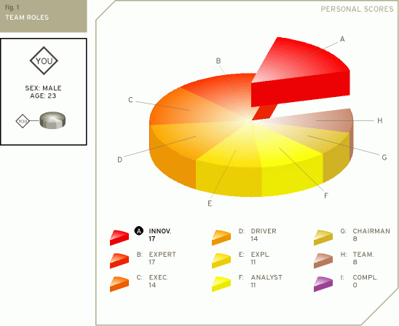  
TABLE – HJM1

TABLE – HJM2

## Dan Steer (ISFJ) Test results

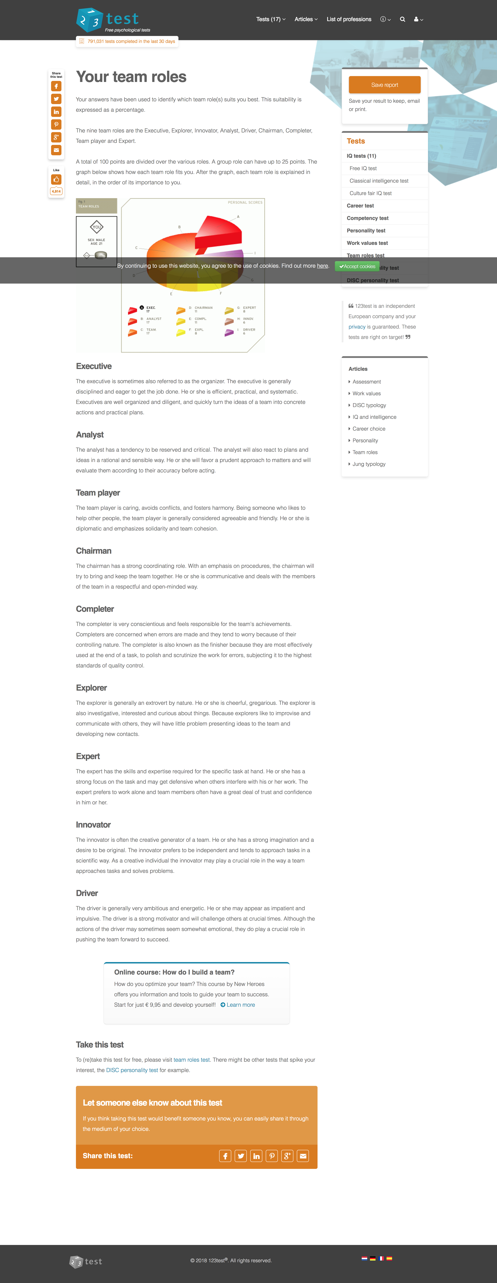  
TABLE – DS1

TABLE – DS2

## Hüseyin Sert (ENFJ) Test Results

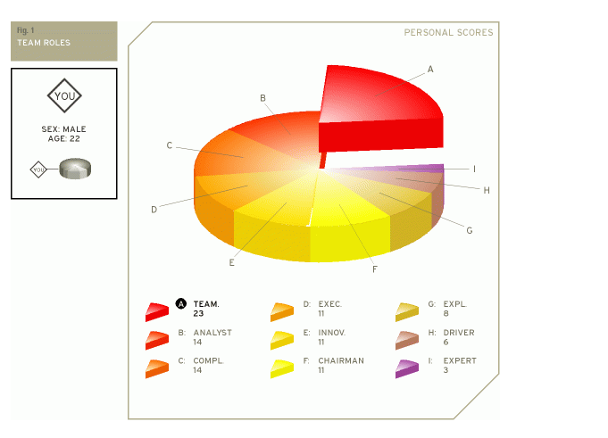  
TABLE – HS1

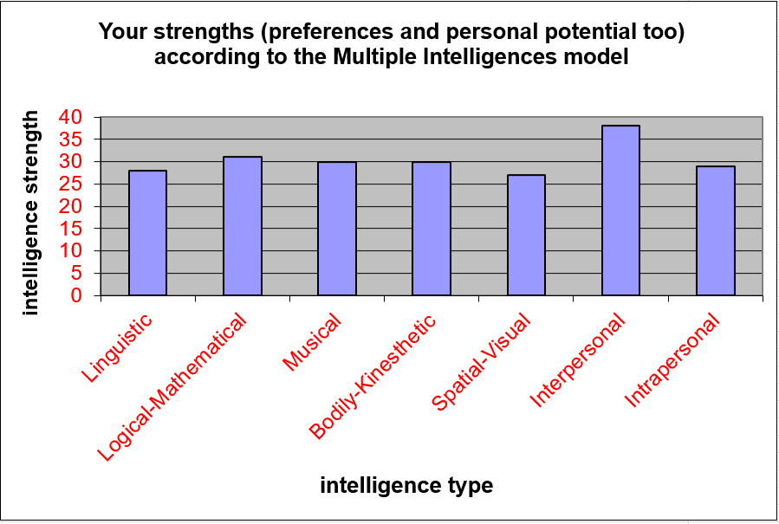  
TABLE – HS2

## Jesse Bat (ENFP) Test Results

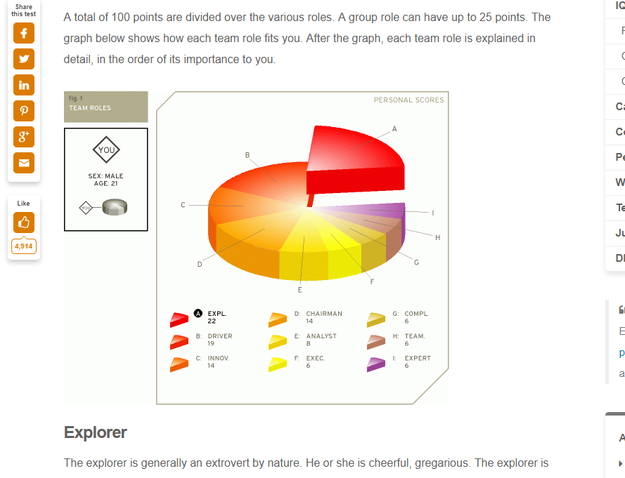  
TABLE – JB1

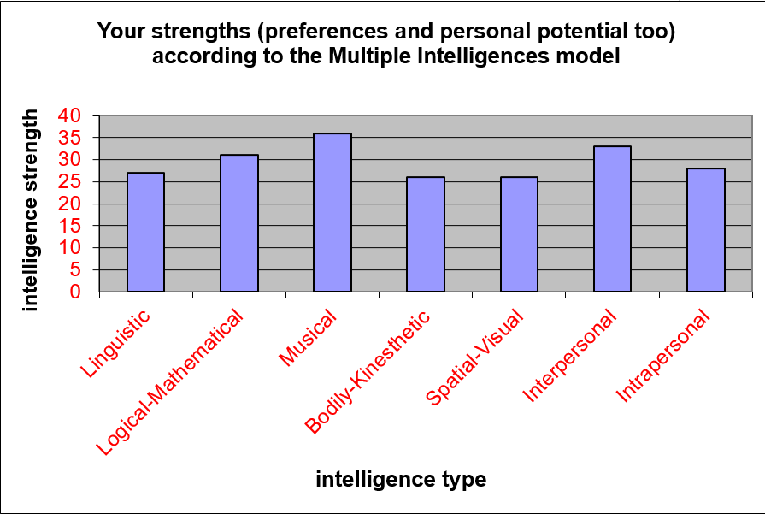  
TABLE - JB2